«ҚАЗАҚ ҰЛТТЫҚ АГРАРЛЫҚ ЗЕРТТЕУ УНИВЕРСИТЕТІ»  КОММЕРЦИЯЛЫҚ ЕМЕС АКЦИОНЕРЛІК ҚОҒАМЫ  Қазақстан Республикасы,  050010, Алматы қаласы,  Абай даңғылы, 8  Сайт: https://www/kaznaru.edu.kz | 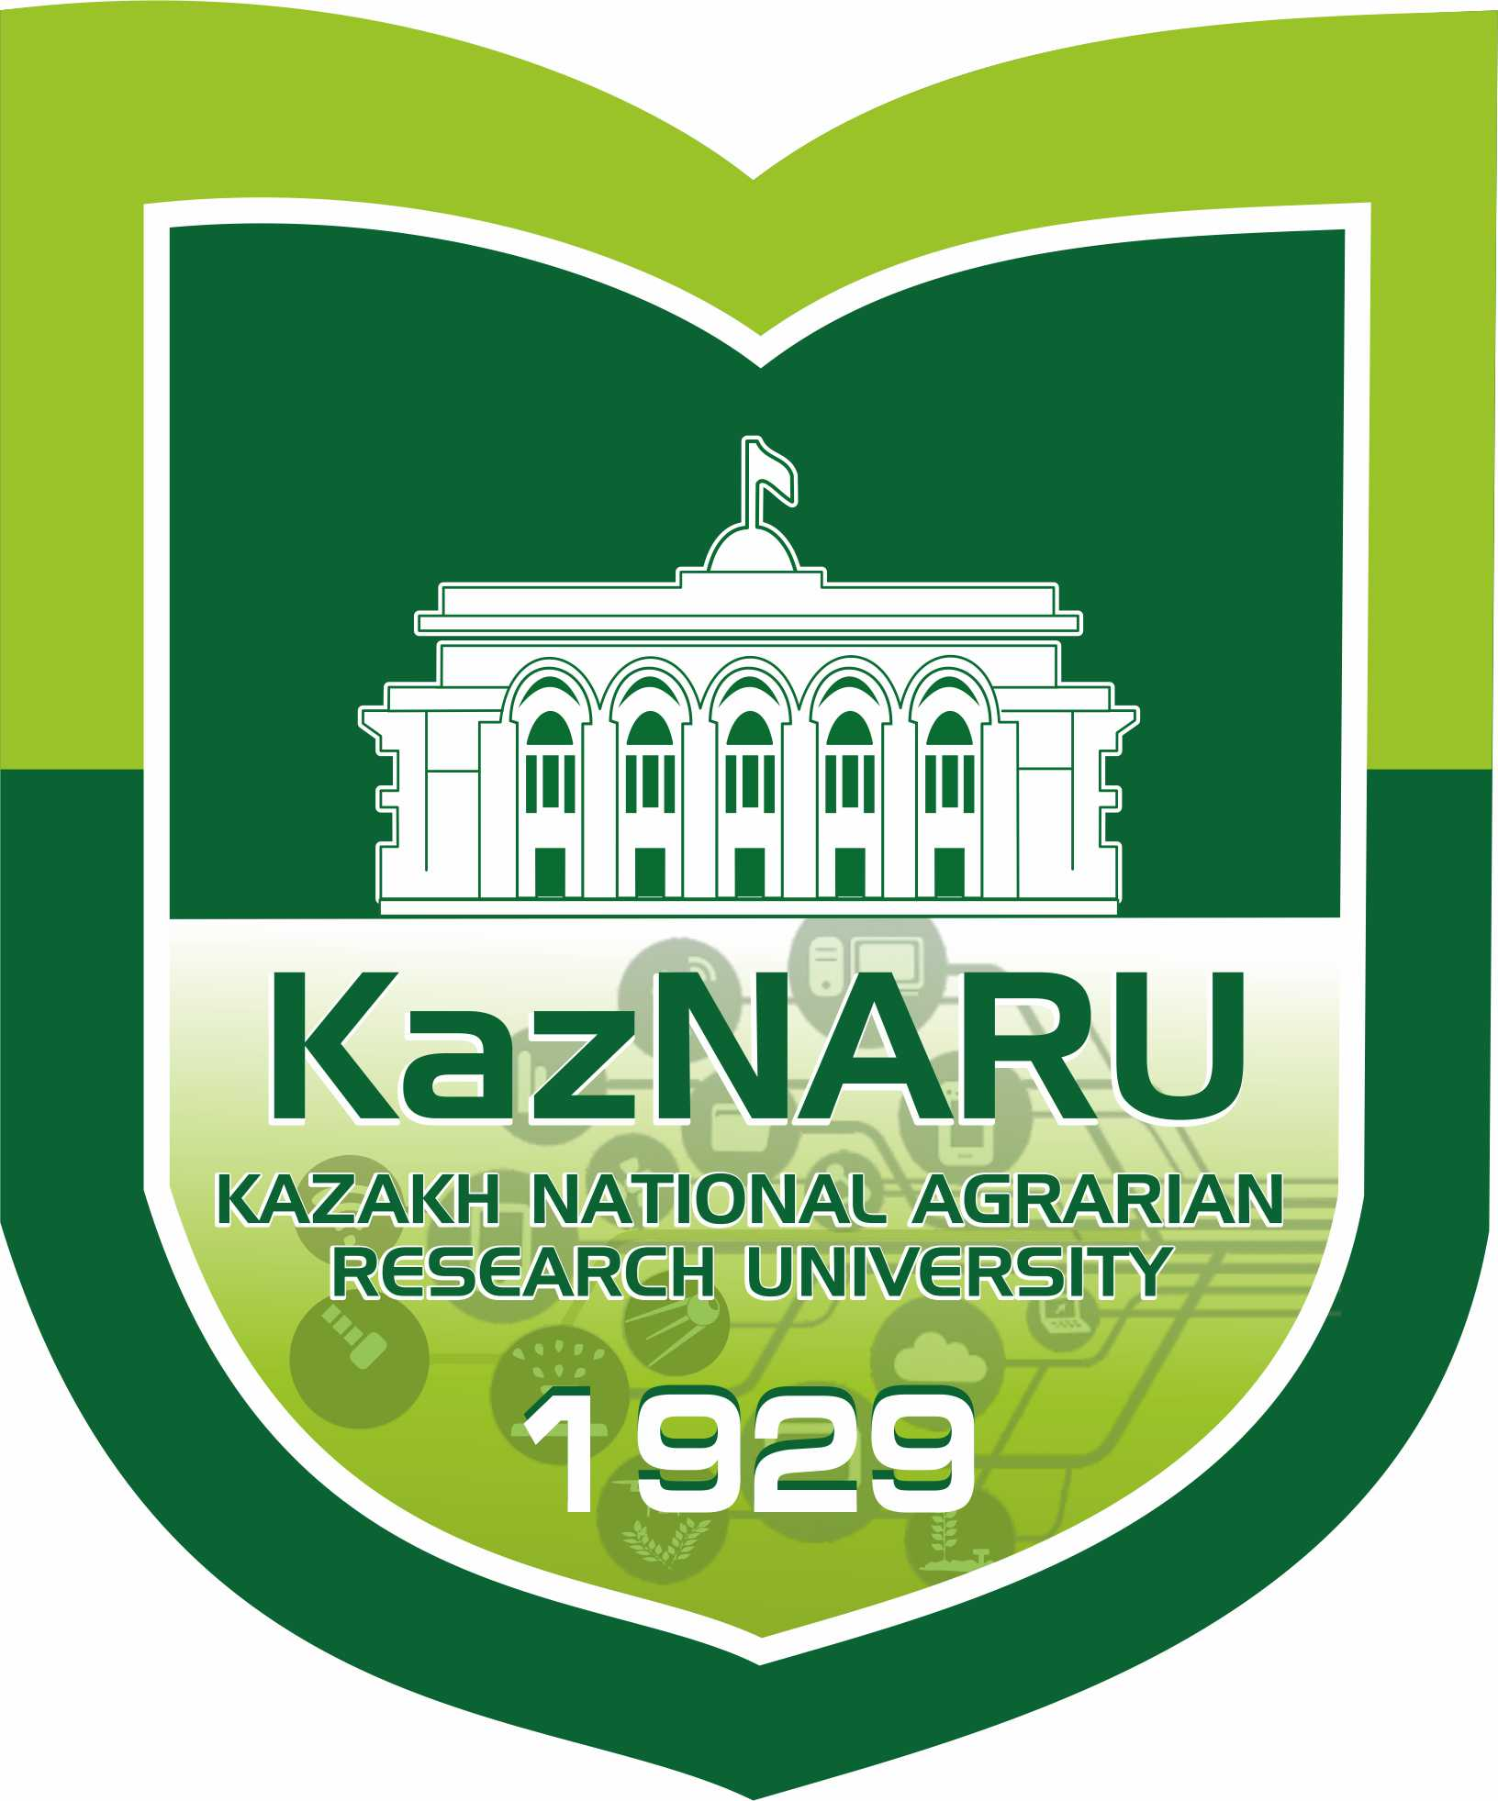 | NON-COMMERCIAL JOINT-STOCK COMPANY «KAZAKH NATIONAL AGRARIAN RESEARCH UNIVERSITY»  Republic of Kazakhstan  050010, Almaty, Abay Avenue, 8  Website: https://www.kaznaru.edu.kz

INFORMATION LETTER
On the International Scientific and Practical Conference
Dedicated to the 80th Anniversary of Academician of the National Academy of Sciences of the Republic of Kazakhstan, Doctor of Biological Sciences, Professor
Abay Orazovich Sagitov
On the topic: «Plant Protection – Green World»

Dear colleagues!

We invite you to participate in the International Scientific and Practical Conference «Plant Protection – Green World», dedicated to the 80th anniversary of Academician of the National Academy of Sciences of the Republic of Kazakhstan, Doctor of Biological Sciences, Professor Abay Orazovich Sagitov, which will be held on September 12, 2025.
The purpose of the conference is to exchange scientific knowledge and experience in the field of plant protection, discuss current issues, achievements, and innovative methods in this area. The conference aims to promote scientific research focused on sustainable and efficient agriculture, biodiversity conservation, ecological balance, as well as the development of science and education in the fields of plant protection, quarantine, biotechnology, and ecology.
Participation in the conference provides a platform for interaction between scientists, researchers, doctoral and master's students, and specialists from various fields, fostering the creation of new scientific and practical solutions to improve plant health and food security.
Participation in the conference is free of charge.
Based on the conference results, a special issue of the journal «Research, Results» (included in the QAСSHE database) will be published, featuring articles that meet the specified formatting requirements.
Authors are responsible for the quality of the submitted material. The text is considered final and is not subject to editing. The Organizing Committee reserves the right to select materials for publication. Submitted materials will undergo expert review by the editorial board, which will decide on their publication. Materials that do not pass the review process will not be returned to the authors. Additionally, materials submitted after the deadline or not formatted according to the requirements will not be considered or returned to the authors.
Participation Conditions:
Participation is determined by the Conference Organizing Committee based on the official application submitted by the participants. Travel expenses for participation are covered by the sending institution.
Submission Guidelines and Deadlines:
Applications and materials, including the topic of presentations and a peer-reviewed article for publication, should be submitted via email by May 30, 2025.
Conference Format:
Both online and offline participation options are available.
Conference Working Languages:
Kazakh, Russian, and English.
Contact Information:
For all inquiries regarding the organization of the conference, please contact:
Gulnur Suleimanova, е-mail: gulnur.suleimanova@kaznaru.edu.kz
Lyazzat Zhaylybayeva, е-mail: lyazzat_0204@mail.ru
Aidana Kharipzhanova, е-mail: aidana.kharipzhanova@kaznaru.edu.kz

As part of the Conference, the following sections will be organized:

№ | Conference Sections | Full Name of the Responsible Person | Contact Phone Numbers
1 | Innovative, Molecular, and Biological Technologies in Plant Protection | Aidana Kharipzhanova | +7 701-127-58-94
2 | Environmentally Safe, Integrated, and Comprehensive Methods in Plant Protection and Quarantine | Lyazzat Zhaylybayeva | +7 778-808-39-90

DEAR PARTICIPANTS, PLEASE CAREFULLY REVIEW THE ARTICLE FORMATTING REQUIREMENTS!

ARTICLE FORMATTING REQUIREMENTS

The article is published in Kazakh, Russian, and English. The text of the article must be prepared in MS Word, with a volume of 5 to 7 pages and must contain original research results.
Review articles based solely on literary sources are not accepted.
The font of the text is Times New Roman, Times Kaz, font size – 12, spacing – 1, paragraph – 1, margins at the top and bottom – 2 cm, left and right – 2 cm.
UDC (upper left corner), followed by a space, then the author's (or authors') last name and initials in bold, centered. After another space, the institution name in italics where the author(s) work or study. After another space, the article title in uppercase, centered.
Before the main text, an abstract in the original language (80-100 words) and keywords (8-10) must be provided. The text must be properly edited and include the following sections: Introduction, Materials and Methods, Research Results and Discussion, Conclusions, and References. After the references, the authors' last names and initials, article title, abstract, and keywords must be provided in two additional languages. Figures and diagrams must be clear. In the references, all authors/co-authors of the cited publication must be listed.
Section titles (Introduction, Materials and Methods, Research Results, Discussion of Results, Conclusions) must be indented from the left margin, bold, and without a period.
Underlining, bold, and italics within the text are not allowed.
Articles that do not meet the specified requirements will not be accepted for publication.

APPLICATION FORM

Full Title of the Article (Presentation)
Affiliation (Full Name of the Institution)
Full Name of the Author(s), Academic Degree, and Title (if applicable)
Form of Participation:
- In-person participation with publication
- Remote participation with publication
Conference Section
E-mail, Contact Phone Number

ARTICLE TEMPLATE
UDC

Abuov A.A.

Kazakh National Agrarian Research University, Almaty. Kazakhstan

Biological protection of plants

Abstract (no more than 80-100 words)
Keywords (no more than 8-10 words, in italics)
Introduction
Materials and Methods
Results and Discussion
Conclusion
References
Abstract in Kazakh, Russian, and English

Organizing Committee Address:
050010, Almaty, Abay Ave. 8
Kazakh National Agrarian Research University
Building No. 4, Office No. 423

Best regards,
Organizing Committee

